**INTRODUCTION**

In spite of the use of social media and internet as the massive way to advertise something, nowadays we keep seeing advertising in the middle of the cities and streets like posters or billboards. This means that promote a product or event through posters among the city is an old but still efficient way to publicize. So, the question that I will try to answer in this project is: where would you put an advertising in a city like Bogotá in order to impact the greatest number of people?

Even though the impact of a publicity depends on other factors like what product or event are your promoting, what are your target customers and what is the strategy used in the poster, to choose a correct place to show your advertising can be an advantage and also the definitive factor when we measure the success or fail of the publicity. It doesn’t have sense to spend many dollars for a poster if at the end it will be display in an incorrect place and nobody will see it.

Hence, we should choose areas with a good visibility where you can impact the right audience. That’s why it is always a good idea to show our advertising in public spaces, events, companies, restaurants, hotels, coffee shops, shopping centers, and trending places where there is a big affluent of people.

Therefore, the objective in this project will be found the busiest areas in the city of Bogotá where we can put our advertising and get positive results.

**DATA**

The data is based in the city of Bogotá, the capital city of Colombia. The city is divided into 20 different borough and we will use foursquare API to identify the venues for each borough and neighborhood.

So, I will get information about venues like name, ID, location and category from Foursquare API. I also will use a table like the following with latitude and longitude of every location in Bogotá.

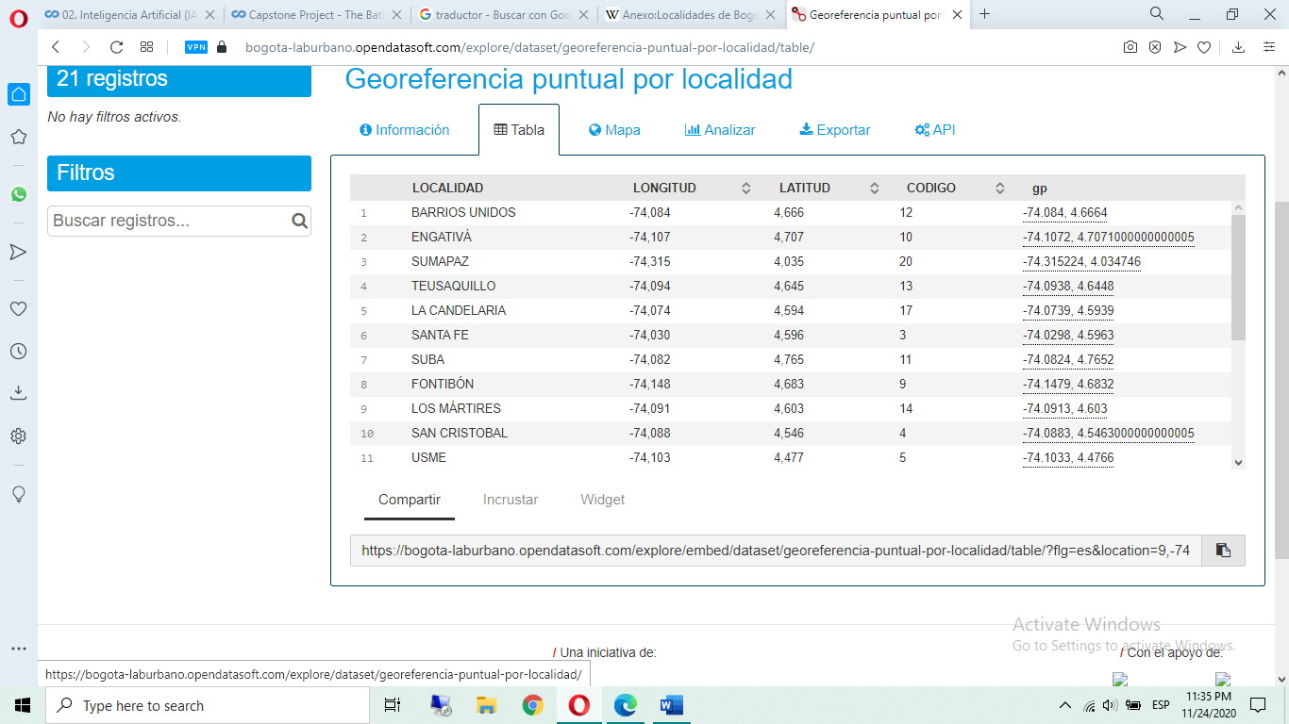

Additionally, I will use data of population, where we can identify the number of women and men in every locality, the number of people per kilometer.

